**Experiment No. 8**

**Aim : -** Conduct Function Point Analysis(FPA) for the project.

**Theory : -**

The Functional Point Analysis (FPA) is a one of the most popularly used software

estimation technique to measure the functional size of the software work i.e. It is a

method or set rules to measure the amount of software functionalities and software

size of the software developed product. It depends on logical view flow of the

application i.e. the number of functionalities delivered to the users. The Functional

Point (FP) is the measurement of functional size of the software application.

When a new project comes to organisation, the organisation starts planning and

estimation on that project in terms of schedule time, cost, resources, etc. The

estimation process of software product includes the testing phase in terms of every

functionality of the application, so the name shows functional point analysis.

There are multiple parameters in functional point analysis process calculation. They

are as follows:

• External Inputs(EI)

• External Outputs(EO)

• External Inquiries (EI)

• Internal Logic Files(ILF)

• External Logic Files(ELF)

1. External Inputs(EI): It is a elementary input parameter which is used in

functional point analysis process when the input data’s to the application are

arranged from the external sources like input screens or business documents or

external databases or external tables or files i.e. the inputs to the application

from outside but within business criteria boundary.

2. External Outputs(EO): In this elementary process the processed data will be

sent to the output in externally i.e. the generated response in terms of log

reports or files. This report or files are used as an input for other application.

The output screen or reports are examples of EO.

3. External Inquiries(EI): It is an elementary parameter, which provides

relationship between input and output components to retrieve the

response/output. The interrupts are the example of external inquiries.

4. Internal Logic Files(ILF): In this process the group of interrelated or logical

data’s are stored inside the system with related to the application standard. The

input data’s are processed by the application to stored in a file with logical

structure. The database or directories are the examples of it.

5. External Logic Files(ELF): It is also known as external interface files where

the group of logical interrelated external files are stored for reference purpose

and used by the software application. It is externally maintained to validate/get

the data from that file. The shared database or shared systems are the examples

of it.

**Output : -**

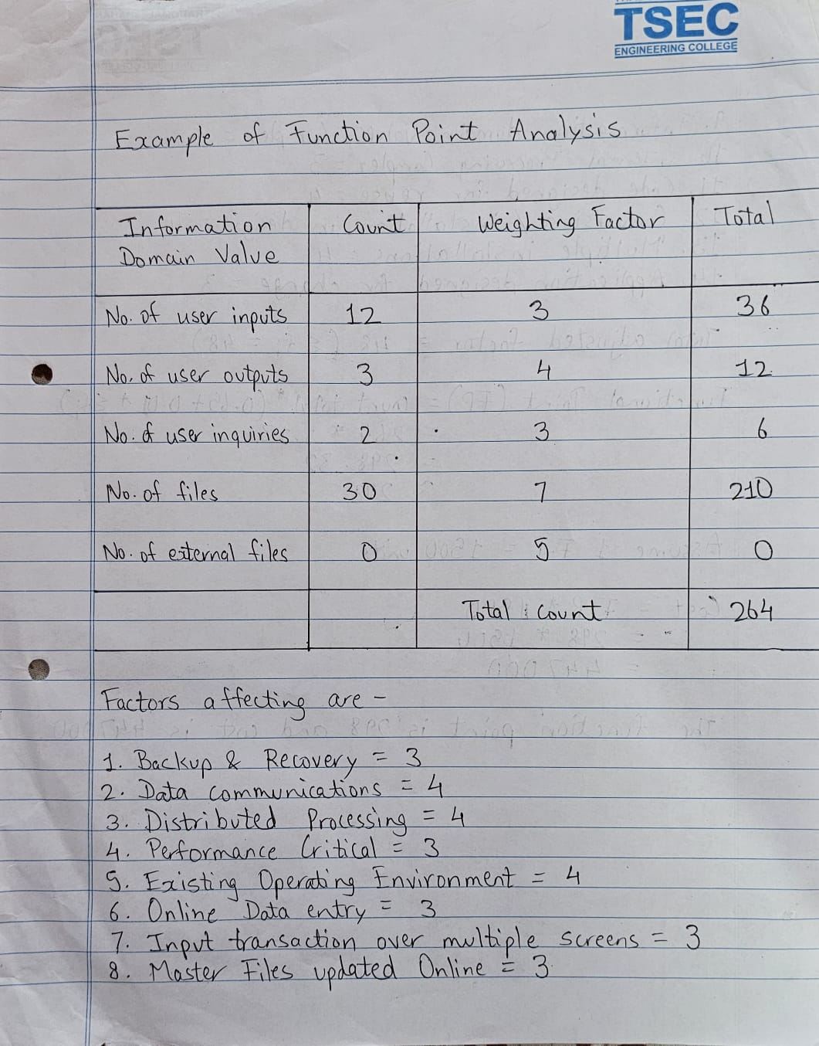

**Conclusion : -**

Hence we have understood the implementation of Function Point.